**Team**

Carlos Parlour

**Abstract**

This database will

**Mission Statement**

**Mission Objectives**

To maintain data on campuses

To maintain data on buildings

To maintain data on departments

To maintain data on Major declaration

To maintain data on staff

To maintain data on courses

To maintain data on students

Perform searches on campuses

Perform searches on buildings

Perform searches on departments

Perform searches on staff

Perform searches on courses

Perform searches on students

Track the status of classes

Track the status of rating

Report on classes

Report on staff

Report on courses

Report on students

**ER Model**

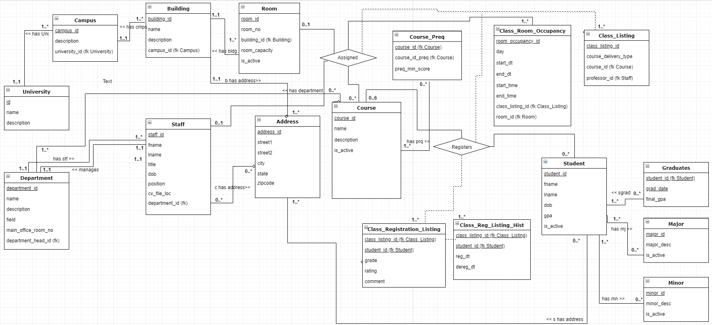

**Major User Views**

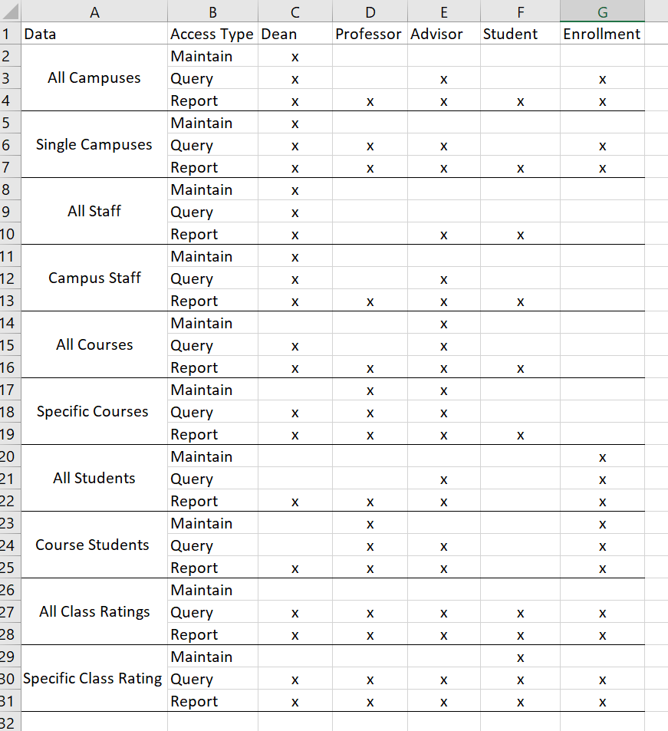

**Use Cases**

**Case name:** Anyone searches classes

Actor: Student, Dean, Professor, Enrollment Officer

Steps:

1. User clicks “Search Classes” button
2. Parameters for search are entered
3. Results appear

**SQL Statements**

SELECT *

FROM Class_Listing cl

JOIN Course c on c.course_id = cl.course_id

left outer JOIN Class_Room_Occupancy cro on cro.class_listing_id = cl.class_listing_id

left outer JOIN Room r on r.room_id = cro.room_id

JOIN Staff s on s.staff_id = cl.professor_id

left outer JOIN Building b on b.building_id = r.building_id

left outer JOIN Building_Addr ba on ba.building_id = b.building_id

left outer JOIN Campus cmp on cmp.campus_id = b.campus_id

Expected: Displays all courses, courses for computer science department, courses as otherwise specified by search terms

Actual: not all class listings were displayed, edited query above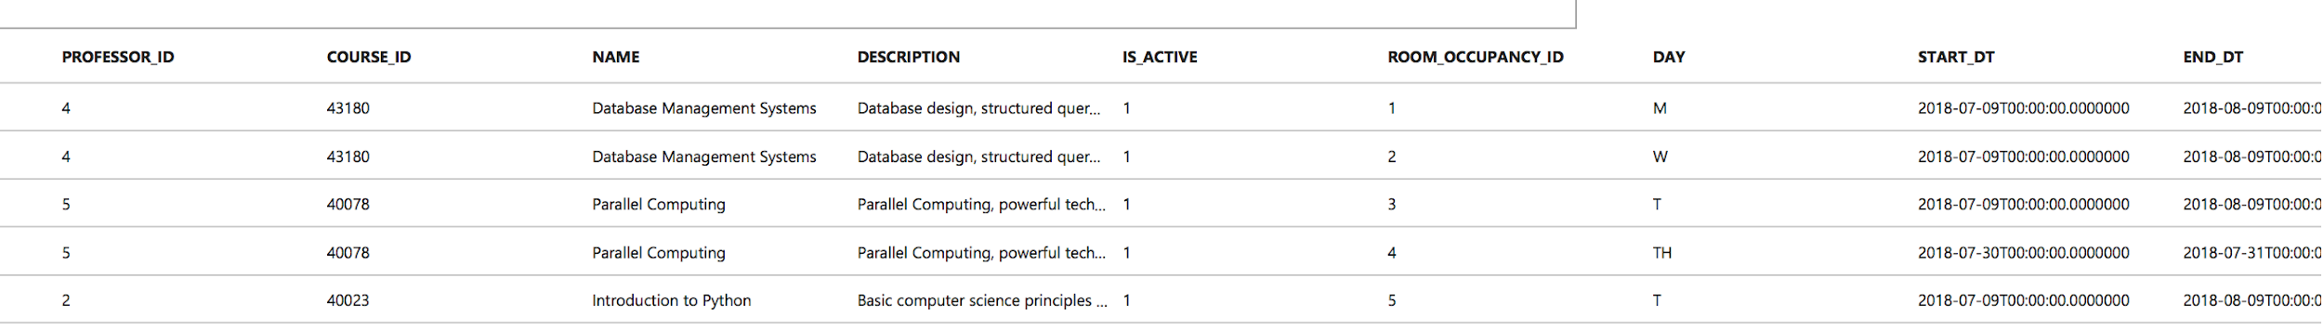

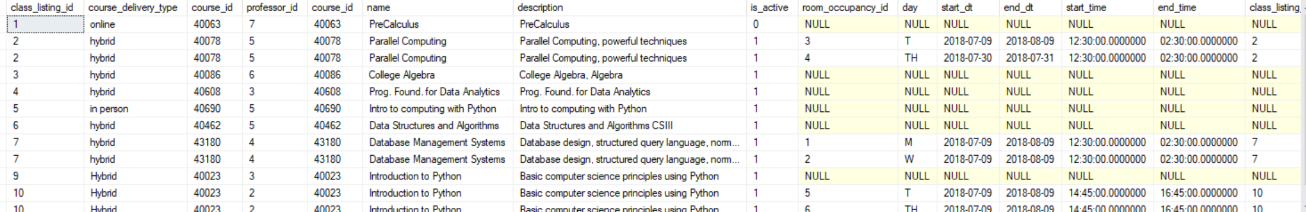

____________________________________________________________________________

**Case name:** Student compares class ratings

Actor: Student

Steps:

1. User searches classes and results displayed
2. User selects results to compare
3. “Compare Courses” button clicked
4. Sample of weekly schedule is displayed, showing class times and locations
5. Course/Instructor reviews are displayed in side panel, grouped by instructor

**SQL Statements**

SELECT *

FROM Class_Listing cl

JOIN Course c on c.course_id = cl.course_id

left outer Join Course_Dept cd on cd.course_id = c.course_id

left outer JOIN Class_Room_Occupancy cro on cro.class_listing_id = cl.class_listing_id

left outer JOIN (SELECT cl.course_id, professor_id, sum(rating)/count(rating) overall_course_rating

FROM Class_Registration_Listing crl JOIN Class_Listing cl on cl.class_listing_id = crl.class_listing_id

GROUP BY cl.course_id, cl.professor_id) a on a.course_id = cl.course_id and a.professor_id = cl.professor_id

left outer JOIN Room r on r.room_id = cro.room_id

left outer JOIN Staff s on s.staff_id = cl.professor_id

left outer join Building b on b.building_id = r.building_id

left outer JOIN Building_Addr ba on ba.building_id = b.building_id

left outer JOIN Campus cmp on cmp.campus_id = b.campus_id

WHERE ; -- where dynamically updated parameters match query

Expected: display all available information about courses offered along with the overall rating for the course and professor matching the class_listings

Actual: not all class_listings displayed, edited query above

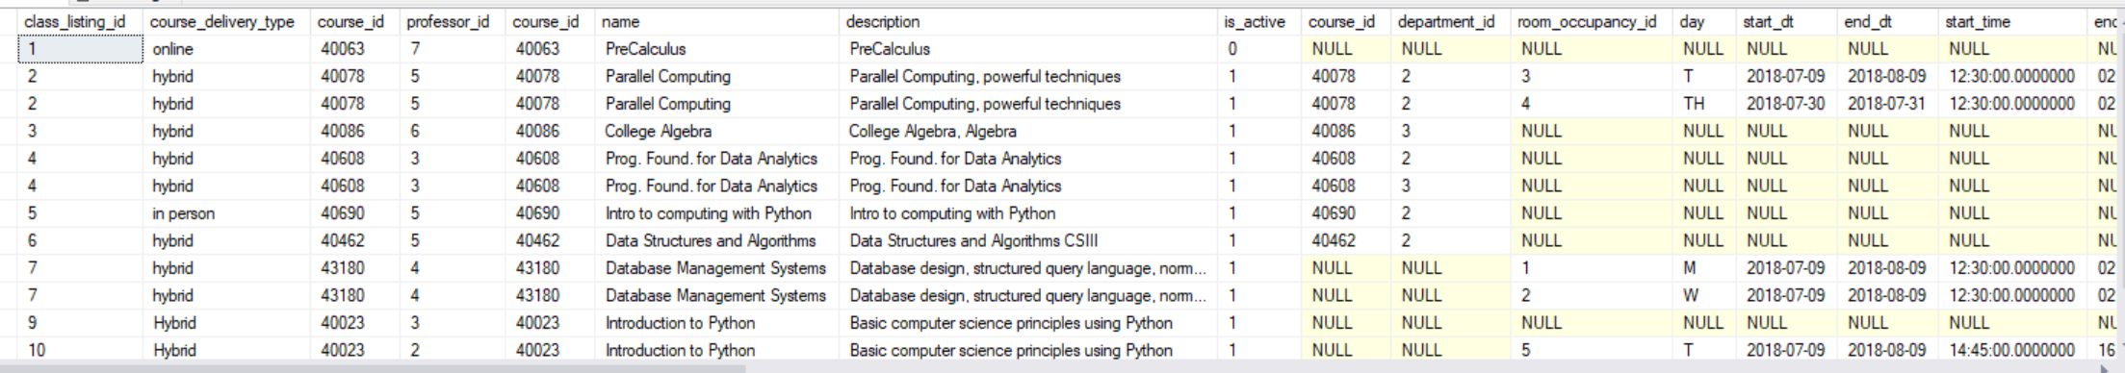

____________________________________________________________________________

**Case name:** Student adds course for registration

Actor: Student

Steps:

1. User searches classes and results displayed
2. User selects course
3. “Add to Schedule” button is clicked
4. Course is added to registration ‘cart’
5. Registration is completed by clicking “Finalize Registration” button on registration page

**SQL Statements**

INSERT into Class_Registration_Listing (class_listing_id, student_id)

values (4,4);

Expected:new row added to table

Actual: as expected

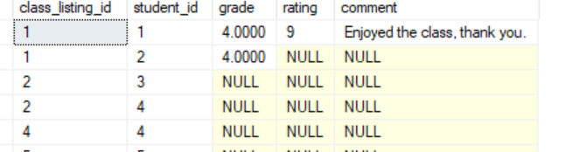

On Insert Trigger

CREATE TRIGGER insClassRegList

ON Class_Registration_Listing

FOR INSERT

AS

INSERT INTO Class_Reg_Listing_Hist (class_listing_id, student_id, reg_dt)

SELECT class_listing_id, student_id, CURRENT_TIMESTAMP

FROM Inserted

GO;

Expected: inserted value from class_registration_listing is inserted into class-reg_listing_hist with a timestamp of the insertion time

Actual:as expected

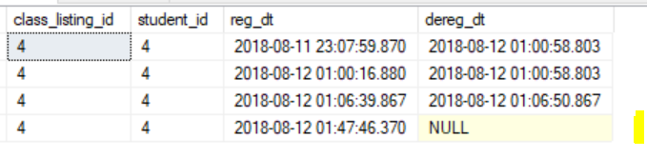

____________________________________________________________________________

**Case name:** Student removes class from schedule

Actor: Student

Steps:

1. User clicks “Remove Classes” button
2. Student selects class
3. Student presses “Remove from schedule”

**SQL Statements**

DELETE FROM Class_Registration_Listing

WHERE class_listing_id = 4 and student_id = 4

Expected: row deleted

Actual: as expected

SELECT * FROM class_registration_listing where class_listing_id = 4 and student_id = 4

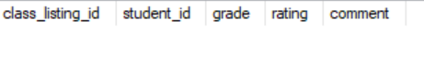

On Delete Trigger:

CREATE TRIGGER delClassRegList

ON Class_Registration_Listing

AFTER Delete

AS

BEGIN

UPDATE crh

set dereg_dt = CURRENT_TIMESTAMP

FROM Class_Reg_Hist_Listing crh

JOIN DELETED d on crh.class_listing_id = d.class_listing_id and crh.student_id = d.student_id

where crh.reg_dt is not null and crh.dereg_dt is null

END

GO;

Expected: dereg_dt is updated to show the current time when the update occurred

Actual: as expected

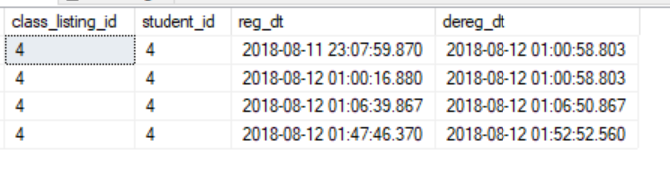

____________________________________________________________________________

**Case name:** Student updates address

Actor: Student

Steps:

1. Student clicks Update Address button
2. Current address information is displayed
3. Student makes changes and clicks save

**SQL Statements**

UPDATE ad

SET street1 = '124 hollywood', street2 = null, city = 'austin', state = 'texas', zipcode = 77012

FROM Address ad

JOIN Student_Addr sa on sa.address_id = ad.address_id

WHERE sa.student_id = 1

select address_id, street1, street2, city, state, zipcode

from Address

where address_id = 1

Expected: student address updated

Actual: as expected

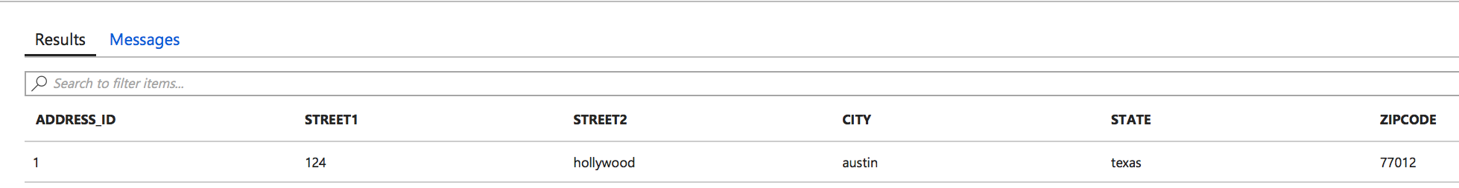

_______________________________________________________________________________________

**Case name:** Student review classes registered

Actor: Student

Steps:

1. Student clicks Review Class Registration
2. Class registration information displayed

**SQL Statements**

SELECT a.*, crl.*

FROM Class_Registration_Listing crl

JOIN (

SELECT student_id,count(class_listing_id) num_classes_reg_total

FROM Class_Reg_hist_Listing

WHERE student_id = 1 and reg_dt between '2018-07-01' and '2018-10-01' and dereg_dt is null

GROUP BY student_id) a on a.student_id = crl.student_id

Expected: displayed class registration information with grade

Actual: as expected

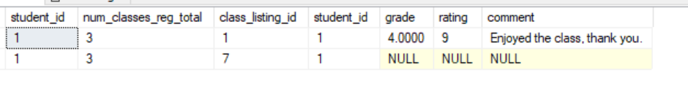

____________________________________________________________________________

**Case name:** Enrollment officer searches for student

Actor: Enrollment Officer

Steps:

1. User clicks Search Student button
2. Parameters for search are entered, options first name last name, dob, course history
3. Enrollment officer clicks search
4. Results are displayed

**SQL Statements**

SELECT *

FROM Student s

JOIN Class_Reg_Hist_Listing crh on crh.student_id = s.student_id

WHERE s.fname = ‘carlos’

Expected: displayed registered courses for students with first name Carlos

Actual: as expected



____________________________________________________________________________

**Case name:** Enrollment reviews number of active students

Actor: Enrollment Officer

Steps:

1. User clicks Review Student Statistics
2. number of active students displayed

**SQL Statements**

SELECT count(is_active) num_active_students

FROM Student

WHERE is_active = 1

Group by is_active

Expected: number of active students displayed

Actual: as expected



____________________________________________________________________________

**Case name:** New Student is enrolled

Actor: Enrollment Officer

Steps:

1. User clicks “New Student” button
2. New student id is generated and displayed, fields Major, Minor, Graduation_Date, and GPA are null
3. Student information is entered for required fields
4. All information is displayed for confirmation
5. “Complete Enrollment” button is clicked

**SQL Statements**

INSERT INTO Student

VALUES (17,'jennifer','Boake','1989-01-01',1);

select student_id, fname, lname,dob, is_active

from Student

where fname = 'jennifer'

Expected: new tuple added to table

Actual: as expected



____________________________________________________________________________

**Case name:** Student dob or name is edited

Actor: Enrollment Officer

Steps:

1. Officer searches student
2. Enrollment officer clicks “Edit”
3. Fields for first name, last name, and date of birth are editable.
4. Officer makes edits and clicks Save
5. Information is displayed for review, officer clicks Confirm Changes button

**SQL Statements**

Update Student

set DOB = '1989-12-15'

where student_id = 7

Expected: date of birth field is updated for row with student_id 7

Actual: as expected

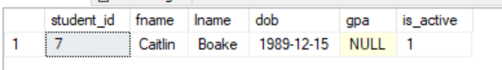

____________________________________________________________________________

**Case name:** Duplicate Student is deleted

Actor: Enrollment Officer

Steps:

1. Officer searches student
2. Enrollment officer clicks “List as Duplicate” button
3. Window appears with warning, officer clicks “confirm delete” button
4. Student entry is scheduled to be deleted from database

**SQL Statements**

DELETE FROM Student

WHERE student_id = 7

(1 row affected)

Expected: row with student_id 7 is removed from table

Actual: as expected

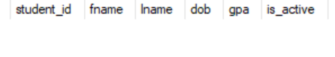

____________________________________________________________________________

**Case name:** Student adds rating to class

Actor: Student

Steps:

1. Student selects “Display Class Schedule”
2. Student select submit feedback next to each course.
3. Student selects save once completed.

**SQL Statements**

UPDATE Class_Registration_Listing

SET rating = 9, comment = 'Enjoyed the class, thank you.'

WHERE student_id = 1 and class_listing_id = 1

Expected: fields rating and comment are updated with data

Actual: as expected

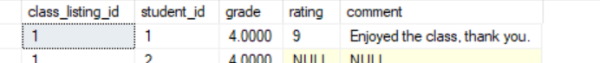

____________________________________________________________________________

**Case name:** Student declares major

Actor: Advisor

Steps:

1. User searches and locates Student
2. Advisor clicks Edit Student button
3. Student’s major is entered in to Major field
4. All Information displayed for confirmation
5. “Save Changes” button is clicked

**SQL Statements**

INSERT INTO Student_Major

VALUES (6,1002)

Expected: new row is added to student_major table

Actual: as expected

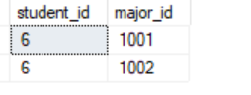

____________________________________________________________________________

**Case name:** Advisor adds Course to database

Actor: Advisor

Steps:

1. Faculty member clicks “Add new course”
2. Course_ID field is automatically populated
3. Enters the name of the course
4. Selects department
5. “Save Changes” is clicked

**SQL Statements**

INSERT INTO Course

VALUES (40025,'Introduction to Python','Basic computer science principles using Python',0)

Expected: new row in course is added

Actual: as expected

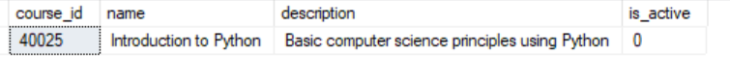

INSERT INTO Course_Dept

VALUES (40608,3)

Expected: new row is added to course_dept when new course is added

Actual: as expected

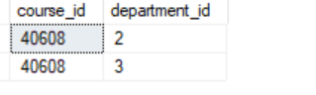

____________________________________________________________________________

**Case name:** Advisor removes course from being offered

Actor: Advisor

Steps:

1. Faculty member clicks “Search Classes”
2. Enters the name of the course
3. Faculty changes the Inactive field from False to True
4. “Save Changes” is clicked

**SQL Statements**

UPDATE Course

SET is_active = 2

WHERE course_id = 40678

-- a value of 1 for is_active= true, 2 = false

Expected: course is_active field is updated to 2

Actual: as expected

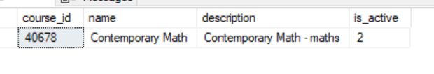

____________________________________________________________________________

**Case name:** Advisor searches class listings

Actor: Advisor

Steps:

1. Faculty member clicks “Search Classes”
2. Enters parameters for search and clicks Search
3. Results appear

**SQL Statements**

SELECT *

FROM Class_Listing cl

JOIN Course c on c.course_id = cl.course_id

left outer JOIN Class_Room_Occupancy cro on cro.class_listing_id = cl.class_listing_id

left outer JOIN Room r on r.room_id = cro.room_id

JOIN Staff s on s.staff_id = cl.professor_id

left outer JOIN Building b on b.building_id = r.building_id

left outer JOIN Building_Addr ba on ba.building_id = b.building_id

left outer JOIN Campus cmp on cmp.campus_id = b.campus_id

Expected: Displays all courses, courses for computer science department, courses as otherwise specified by search terms

Actual: not all class listings were displayed, edited query above



____________________________________________________________________________

**Case name:** Advisor updates class time

Actor: Advisor

Steps:

1. Faculty member searches and locates specific class listing
2. Advisor selects edit
3. Advisor makes changes to time and clicks Save button
4. Advisor clicks Confirm Changes button

**SQL Statements**

UPDATE Class_Room_Occupancy

SET room_id = 10 WHERE room_occupancy_id = 6

Expected: class time is updated in room_occupancy for specific room occ. id  
Actual: as expected



____________________________________________________________________________

**Case name:** Advisor removes student’s class from schedule

Actor: Advisor

Steps:

1. Student is searched and located
2. Advisor clicks Show Classes button
3. Clicks Edit Classes button
4. Selects classes to be removed from schedule
5. Clicks “remove from class schedule” button
6. Confirm, Save

**SQL Statements**

DELETE FROM Class_Registration_Listing

WHERE class_listing_id = 4 and student_id = 4

Expected: specific row is removed from table  
Actual: as expected

before: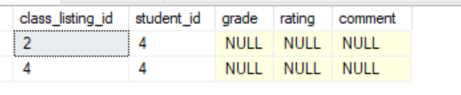

after: 

On Delete Trigger:

CREATE TRIGGER delClassRegList

ON dbo.Class_Registration_Listing

FOR Delete

AS

UPDATE crh

set dereg_dt = CURRENT_TIMESTAMP

FROM Class_Reg_Listing_Hist crh

JOIN DELETED d on crh.class_listing_id = d.class_listing_id and crh.student_id = d.student_id

where crh.reg_dt is not null and crh.dereg_dt is null

GO;

Expected: dereg_dt is updated for specific instance of student registering for class_listing  
Actual: not expected, dereg_dt is changed for all instances of that class_listing_id and student_id combo. Altered Trigger delClassRegList on Class_Registration_Listing table, modification is underlined above.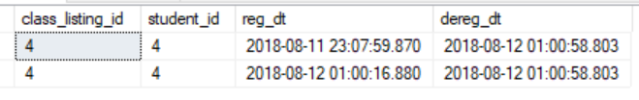

after edit:

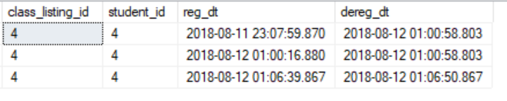

____________________________________________________________________________

**Case name:** Professor searches rating

Actor: Professor

Steps:

1. Professor selects “Overall rating”.
2. Classes are displayed with his or her overall rating and comments

**SQL Statements**

SELECT professor_id, crl.class_listing_id, sum(rating) overall_course_rating

FROM Class_Registration_Listing crl

JOIN Class_Listing cl on cl.class_listing_id = crl.class_listing_id

GROUP BY professor_id, crl.class_listing_id

Expected: Overall rating for class_listings for professor is displayed  
Actual: as expected

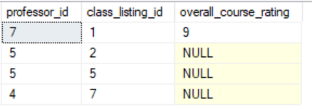

____________________________________________________________________________

**Case name:** Student reviews class grade

Actor: Student

Steps:

1. Student selects “Display Class Schedule”
2. Student selects “Grade” button for specific class
3. Grade for that class is displayed

**SQL Statements**

SELECT grade, class_listing_id

FROM Class_Registration_Listing

WHERE student_id = 2 and class_listing_id = 7

Expected: grade displayed for specific class  
Actual: as expected

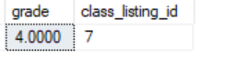

____________________________________________________________________________

**Case name:** Student reviews grades for all classes taken

Actor: Student

Steps:

1. Student selects “Grades” button
2. Grades for all classes that student has taken are displayed

**SQL Statements**

SELECT c.name class_name, grade

FROM Class_Registration_Listing reg

JOIN Class_Listing cl on cl.class_listing_id = reg.class_listing_id

JOIN Course c on c.course_id = cl.course_id

WHERE student_id = 2

Expected: class name and class grades are displayed

Actual: as expected

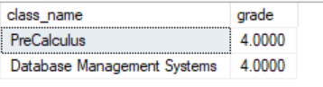

____________________________________________________________________________

**Case name:** Course is offered as Class for semester

Actor: Advisor

Steps:

1. Advisor selects “add class”
2. Advisor selects Course from a list and clicks “list this course”
3. Values class_listing_id and course_id are pre-populated in form
4. Advisor selects room from list
5. Advisor selects professor from list
6. Advisor selects course delivery type from list
7. Advisor enters class dates, and class times

**SQL Statements**

INSERT INTO Class_Listing

VALUES (10,'Hybrid', 40023,2)

Expected: new row is added to class_listing

Actual: as expected

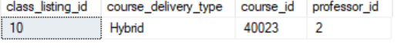

____________________________________________________________________________

**Case name:** Professor updates student grades

Actor: Professor

Steps:

1. Professor clicks Update Grades button
2. A list of classes the professor is teaching is displayed, professor clicks appropriate class
3. A list of students enrolled in this class is displayed
4. Next to each student are columns listing each class assignment
5. Professor enters a grade for a student underneath the appropriate assignment heading
6. Cumulative grade is calculated and updated automatically after professor clicks out of cell
7. Professor clicks Update button

**SQL Statements**

UPDATE Class_Registration_Listing

SET grade = 3.5

WHERE class_listing_id = 7 and student_id = 2

Expected: grade field is updated for student_id 2 with class_listing_id 7

Actual: as expected



____________________________________________________________________________

**Case name:** Professor adds new address

Actor: Professor

Steps:

1. Professor click Add address
2. Enters information
3. Clicks save

**SQL Statements**

INSERT INTO Address

values(8, '1234 Jasperwood', 'Humble', 'tx', '77386');

INSERT INTO Staff_Addr

VALUES (1,8)

Expected: new rows added to tables Address and Staff_Addr

Actual: as expected

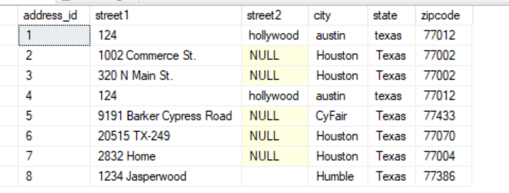



___________________________________________________________________________

**Case name:** Professor removes student’s class from schedule

Actor: Professor

Steps:

1. Student is searched and located
2. Professor clicks Show Classes button
3. Clicks Edit Classes button
4. Selects classes to be removed from schedule
5. Clicks “remove from class schedule” button
6. Confirm, Save

**SQL Statements**

DELETE FROM Class_Registration_Listing  
WHERE class_listing_id = vClassListingId and student_id = vStudentId;

Expected: row deleted

Actual: as expected

SELECT * FROM class_registration_listing where class_listing_id = 4 and student_id = 4



On Delete Trigger:

CREATE TRIGGER delClassRegList

ON Class_Registration_Listing

AFTER Delete

AS

BEGIN

UPDATE crh

set dereg_dt = CURRENT_TIMESTAMP

FROM Class_Reg_Hist_Listing crh

JOIN DELETED d on crh.class_listing_id = d.class_listing_id and crh.student_id = d.student_id

where crh.reg_dt is not null and crh.dereg_dt is null

END

GO;

Expected: dereg_dt is updated to show the current time when the update occurred

Actual: as expected



____________________________________________________________________________

**Case name:** Dean searches for staff member

Actor: Dean

Steps:

1. Dean clicks “search staff”
2. Parameters like first and last name, classes taught, start date, department, and position can be entered
3. Dean clicks “search”
4. Results are displayed

**SQL Statements**

SELECT *

FROM Staff s

left outer JOIN Class_Listing cl on cl.professor_id = s.staff_id

WHERE -- where dynamically updated parameters match

Expected: all staff are available for search, some are displayed based on search parameters

Actual: not all staff are displayed, edited query above

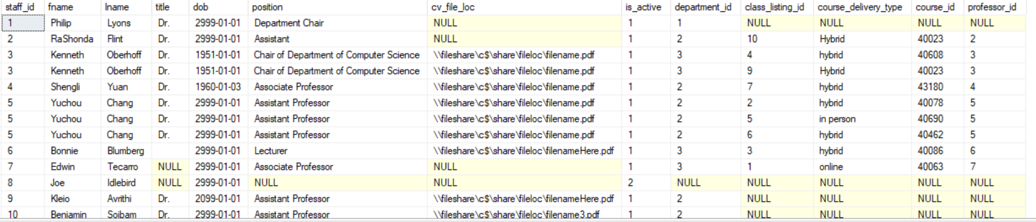

____________________________________________________________________________

**Case name:** Dean adds new Professor to database

Actor: Dean

Steps:

1. Dean clicks New Staff button
2. Staff_id is pre-populated in the form
3. Department and position are selected from lists
4. Professor’s CV is attached by selecting it from a list of already uploaded CVs
5. Dean clicks Save button and confirms information is correct, clicks Confirm button

**SQL Statements**

INSERT INTO Staff

VALUES (12,'Roger','yindeemark','Dr.','1989-01-03','Associate',null,1,1);

Expected: new row inserted into Staff table  
Actual: as expected



____________________________________________________________________________

**Case name:** Dean deletes a duplicate Staff entry

Actor: Dean

Steps:

1. Dean searches for Staff and locates duplicate entry
2. Dean clicks “List as Duplicate” button
3. Window appears with warning, dean clicks “confirm delete” button
4. Staff entry is scheduled to be deleted from database

**SQL Statements**

DELETE FROM Staff

where Staff_id = 13

Expected: staff member marked as duplicate is removed from Staff table

Actual: as expected

before: after: 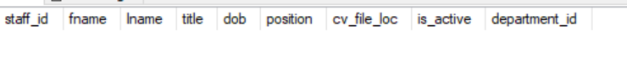

____________________________________________________________________________

**Case name:** Dean reviews number of active staff

Actor: Dean

Steps:

1. User clicks Review Staff Statistics
2. number of active staff displayed

**SQL Statements**

SELECT count(is_active) num_active_staff

FROM Staff

WHERE is_active = 1

Group by is_active

Expected: number of active staff are displayed

Actual: as expected

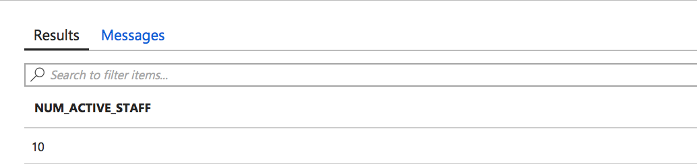

____________________________________________________________________________

**Case name:** Dean updates rooms to building after renovation

Actor: Dean

Steps:

1. Dean clicks “Infrastructure”
2. List of Campuses is displayed, dean selects a campus
3. List of Buildings is displayed, dean selects building
4. List of rooms is displayed
5. Click Add Room button
6. Room information is entered, room_id and building_id are pre-populated in form
7. Dean clicks Save button

**SQL Statements**

INSERT INTO Room

VALUES (15,704,3,'classroom',50,0);

Expected: new row inserted into table Room

Actual: as expected



**Relational Model**

University(university_id, name, description)

Address(address_id, street1, street2, city, state, zipcode)

Campus (campus_id, description, university_id (fk University))

Campus_Addr (campus_id (fk Campus), address_id (fk Address))

Building (building_id, name, description, campus_id (fk Campus))

Building_Addr (building_id (fk Building ), address_id (fk Address))

Room (room_id, room_number, building_id (fk Building), room_capacity, is_active)

Department (department_id, name, description, room_no (fk Room), department_head_id (fk Staff))

Staff (staff_id, fname, lname, title, dob, position, cv_file_loc, department_id (fk Department), is_active)

Staff_Addr(staff_id (fk Staff), address_id (fk address))

Campus_Addr (campus_id (fk Campus), address_id (fk Address))

Course (course_id, name, description, is_active)

Course_Dept(course_id (fk Course), department_id (fk Department))

Course_Preq (course_id (fk Course), course_id_preq(fk Course), preq_min_score)

Class_Listing (class_listing_id, course_delivery_type, course_id (fk Course), professor_id (fk Staff))

Class_Room_Occupancy (room_occupancy_id, day, start_dt, end_dt, start_time, end_time,class_listing_id (fk Class_Listing), room_id (fk Room))

Student (student_Id, fname, lname, dob, GPA, is_active)

Student_Minor(student_id (fk Student), minor_id (fk Minor))

Minor(minor_id, minor_desc, is_active)

Major(major_id, major_desc, is_active)

Student_Major(student_id (fk Student), major_id (fk Major))

Student_Addr(student_id(fk Student), address_id (fk Address))

Graduates (student_id (fk Student), grad_date, final_GPA)

Class_Registration_Listing (class_listing_id (fk Class_Listing) , student_id (fk Student), grade, rating, comment)

Class_Reg_Listing_Hist (reg_hist_id, class_listing_id (fk Class_Listing), student_id (fk Student), reg_dt, dereg_dt)

**Functional Dependencies:**

university_id -> name, description

address_id -> street1, street2, city, state, zipcode

campus_id -> name, description, university_id

building_id -> name, description, campus_id

room_id -> room_number, building_id, room_capaticy, inactive

department_id -> name, description, room_id, department_head_id

staff_id -> fname, lname, title, dob, department_id, position, cv_file_loc, is_active

course_id -> name, description, is_active

course_id, course_id_preq -> preq_min_score

class_listing_id -> course_id, professor_id, course_delivery_type

room_occupancy_id -> day, start_dt, end_dt, start_time, end_time, class_listing_id, room_id

student_id -> fname, lname, is_active, dob, GPA

student_id, grad_dt -> final_gpa

major_id -> major_desc, is_active

minor_id -> minor_desc, is_active

class_listing_id, student_id -> grade, rating, comment

class_listing_id, student_id, date_registered -> date_deregistered

All relations are in 4NF, see BCNF verification at end of document.

**SQL Statements**

These statements below will show one insert, one delete, one update, one aggregate, one joint query query for each entity and its direct relationship if applicable.

----------------------------------------

---- University

----------------------------------------

SELECT * FROM university

--INSERT INTO University

--VALUES (2,'University of Houston','University of Houston')

--UPDATE University

--SET Name = 'University of Houston Downtown'

--WHERE university_Id = 1

--DELETE FROM University

--WHERE University_Id = 2

SELECT count(*) countUniversity FROM University

SELECT u.name as University, c.description as Campus

FROM University u

join Campus c on c.university_id = u.University_Id

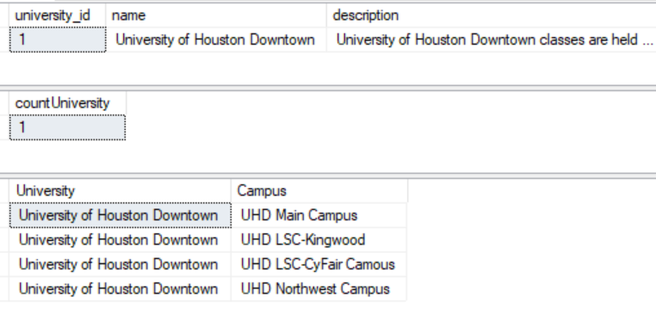

----------------------------------------

---- Address

----------------------------------------

SELECT * FROM address

--INSERT INTO Address

--VALUES (8, '1234 Home Address', 'Apt. 102', 'Houston', 'Texas','77012')

--UPDATE Address

--SET zipcode = 77009

--WHERE address_id = 8

--DELETE FROM Address

--WHERE address_id = 8

SELECT count(*) houston_addresses

FROM address

WHERE city = 'Houston'

SELECT c.description, a.* FROM Address a

join Campus_Addr ca on ca.address_id = a.address_id

join Campus c on c.campus_id = ca.campus_id

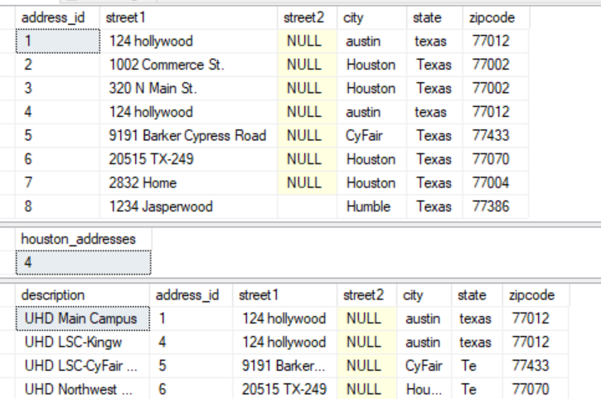

----------------------------------------

---- Campus

----------------------------------------

SELECT * FROM campus

--INSERT INTO Campus

--VALUES (5,'University of Houston - Main Campus',1)

--UPDATE Campus

--SET university_id = 2 WHERE campus_id = 5

--DELETE FROM Campus

--WHERE campus_id = 5

SELECT count(campus_id) UHDMain_CampusCount FROM campus WHERE university_id = 1

SELECT u.Name UniversityName, c.description CampusName, a.* FROM campus c

join university u on c.university_id = u.university_id

join Campus_Addr ca on ca.campus_id = c.campus_id

join Address a on a.address_id = ca.address_id

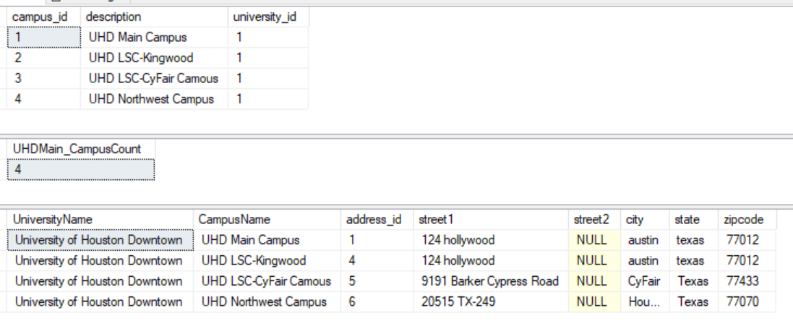

----------------------------------------

---- Campus_Addr

----------------------------------------

SELECT * FROM Campus_Addr

--INSERT INTO Campus_Addr

--VALUES (1,4)

--UPDATE Campus_Addr

--SET address_id = 1

--WHERE campus_id = 1

--DELETE FROM Campus_Addr

--WHERE campus_id = 1 and address_id = 4

SELECT campus_id, count(address_id) numAddressPerCampus FROM Campus_Addr

GROUP BY campus_id

SELECT * FROM Campus_Addr ca

join Campus c on ca.campus_id = c.campus_id

join Address a on a.address_id = ca.address_id

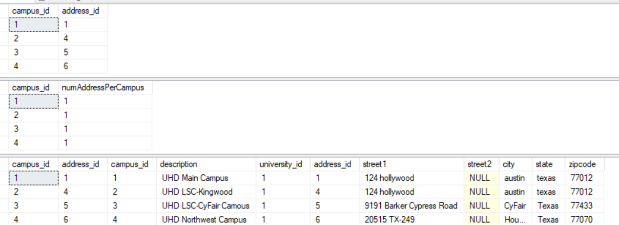

----------------------------------------

---- Building

----------------------------------------

SELECT * FROM building

--INSERT INTO Building

--VALUES (4,'Building 11', 'Corporate Office',4)

--UPDATE Building

--SET description = 'Corporate Office Northwest'

--WHERE building_id = 4

--DELETE FROM Building

--WHERE building_id = 4

SELECT campus_id, count(building_id) numBuildings

FROM BUILDING

GROUP BY campus_id

SELECT b.name BuildingName, c.description CampusName, a.* FROM building b

join campus c on c.campus_id = b.campus_id

join Building_Addr ba on ba.building_id = b.building_id

join Address a on a.address_id = ba.address_id

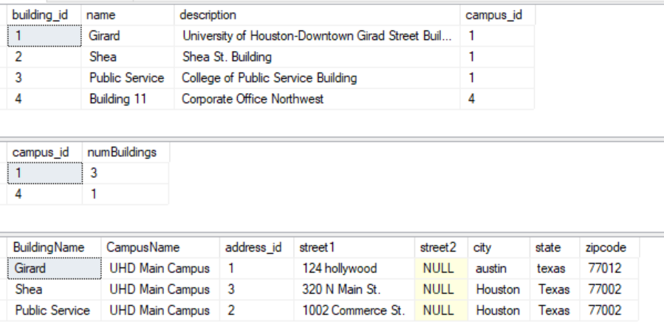

----------------------------------------

---- Building_Addr

----------------------------------------

SELECT * FROM building_addr

--INSERT INTO Building_Addr

--VALUES (4,4)

--UPDATE Building_Addr

--SET address_id = 4 WHERE building_id = 4

--DELETE FROM Building_Addr

--WHERE address_id = 4 and building_id = 4

SELECT building_id, count(*) addressCount

from Building_Addr

Group by building_id

SELECT * FROM building_addr ba

join building b on ba.building_id = b.building_id

join address a on a.address_id = ba.address_id

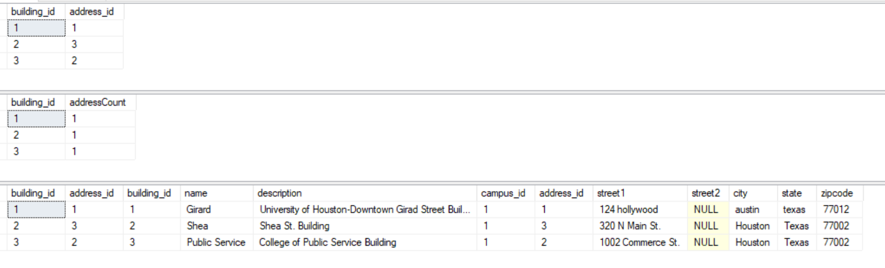

----------------------------------------

---- Room

----------------------------------------

SELECT * FROM room

--INSERT INTO Room

--VALUES (12,1234,4,'Corporate Office Kingwood',30,1);

--UPDATE Room

--SET is_active = 0

--WHERE room_id = 11

--DELETE FROM Room

--WHERE room_id = 12

SELECT r.building_id, count(r.room_id) num_rooms

FROM room r

GROUP BY r.building_id

SELECT r.room_number, r.room_capacity, b.*

FROM room r

join building b on b.building_id = r.building_id

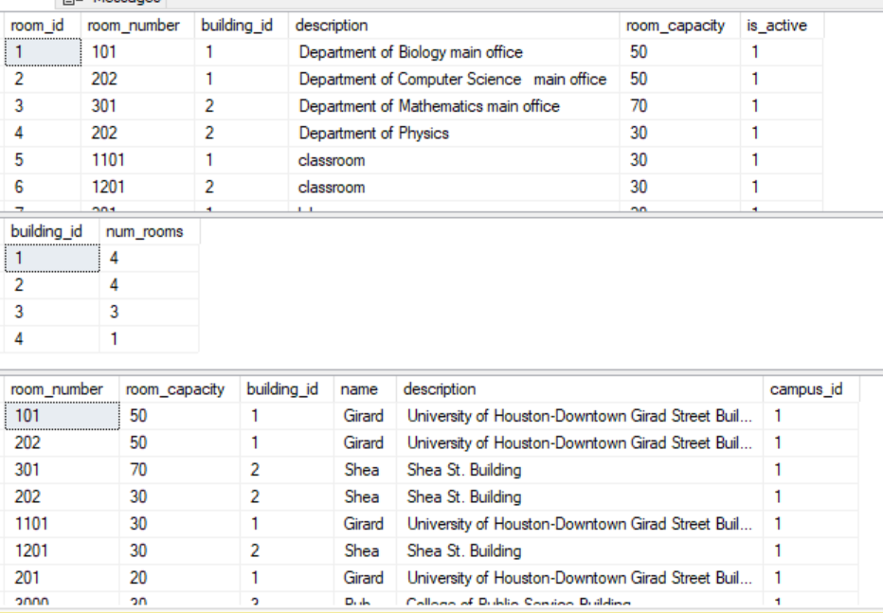

----------------------------------------

---- Student

----------------------------------------

SELECT * FROM student --WHERE Student_id = 7

--INSERT INTO Student (student_id,fname,lname,dob,is_active)

--VALUES (7,'Caitlin','Boake','1989-01-01',1);

--UPDATE Student

--SET DOB = '1989-12-15'

--WHERE student_id = 7

--DELETE FROM Student

--WHERE student_id = 7

SELECT count(is_active) num_active_students

FROM Student

WHERE is_active = 1

GROUP BY is_active

SELECT * FROM Student s

join Student_Addr sa on sa.student_id = s.student_id

left outer join Address a on a.address_id = sa.address_id

left outer join Student_Major smj on smj.student_id = s.student_id

left outer join Student_Minor smn on smn.student_id = s.student_id

join Major m on m.major_id = smj.major_id

join Minor mn on mn.minor_id = smn.minor_id

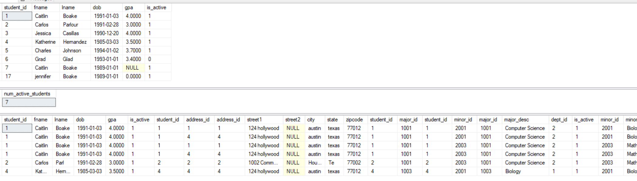

----------------------------------------

---- Major

----------------------------------------

SELECT * FROM major

--INSERT INTO Major

--VALUES (1005, 'English', 2,2)

--UPDATE major

--SET is_active = 1, dept_id = 5

--WHERE major_id = 1005

--DELETE FROM Major

--WHERE major_id = 1006

SELECT dept_id, count(major_id) num_major

FROM major

GROUP BY dept_id

SELECT * FROM major m

join student_major sm on sm.major_id = m.major_id

join Department d on d.department_id = m.dept_id

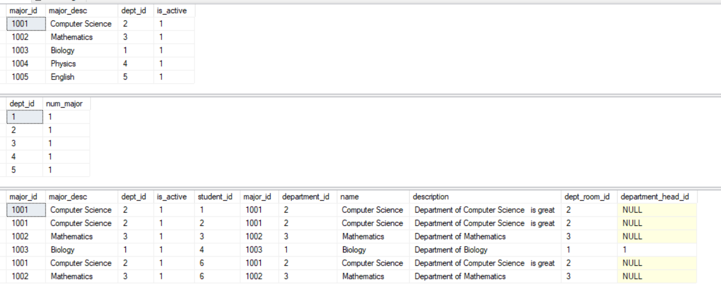

----------------------------------------

---- Minor

----------------------------------------

SELECT * FROM minor

--INSERT INTO Minor

--VALUES (2005, 'English', 5,2)

--UPDATE Minor

--SET is_active = 1, dept_id = 5

--WHERE minor_id = 2004

--DELETE FROM Minor

--WHERE minor_id = 2005

SELECT dept_id, count(minor_id) num_minor

FROM minor

GROUP BY dept_id

SELECT * FROM Minor m

left outer join Student_Minor sm on sm.minor_id = m.minor_id

join Department d on d.department_id = m.dept_id

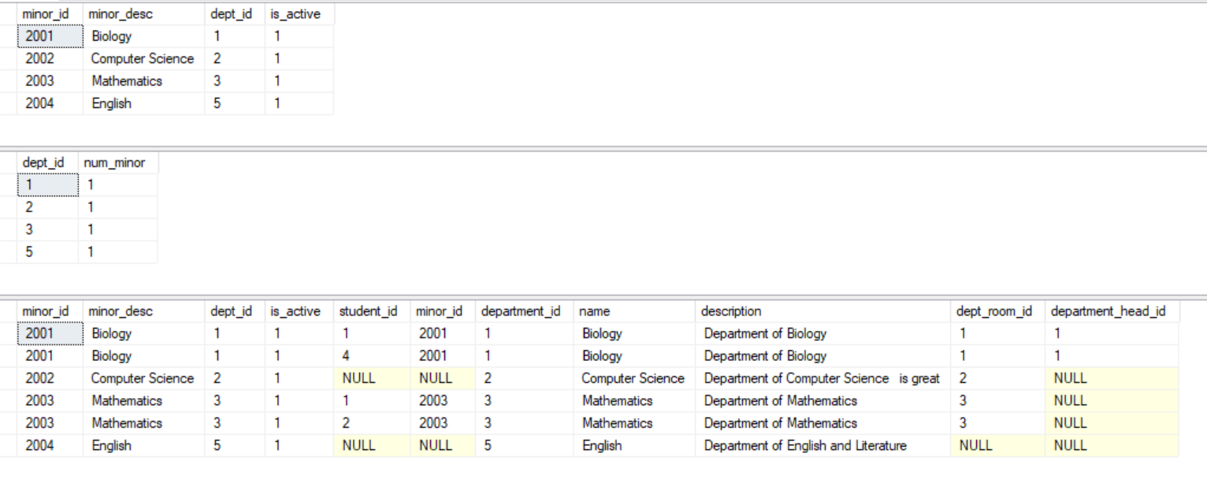

----------------------------------------

---- Student_Major

----------------------------------------

SELECT * FROM student_major WHERE Student_id = 6

--INSERT INTO Student_Major

--VALUES (6,1002)

--UPDATE Student_Major

--SET major_id = 1003

--WHERE student_id = 6 and major_id = 1002

--DELETE FROM Student_Major

--WHERE student_id = 6 and major_id = 1003

SELECT major_id, count(distinct student_id) num_student

FROM student_major

GROUP BY major_id

SELECT * FROM Student_Major sm

join Major m on m.major_id = sm.major_id

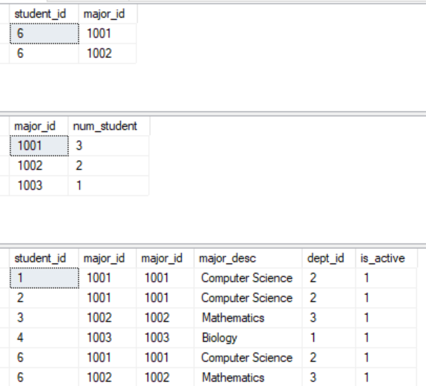

----------------------------------------

---- Student_Minor

----------------------------------------

SELECT * FROM student_minor

--INSERT INTO Student_Minor

--VALUES (6,2004)

--UPDATE Student_Minor

--SET minor_id = 2002

--WHERE student_id = 6 and minor_id = 2004

--DELETE FROM Student_Minor

--WHERE student_id = 6 and minor_id = 2002

SELECT minor_id, count(student_id) NumStudentsWithMinor

FROM student_minor

GROUP BY minor_id

SELECT * FROM Student_Minor sm

join Minor m on m.minor_id = sm.minor_id

join Student s on s.student_id = sm.student_id

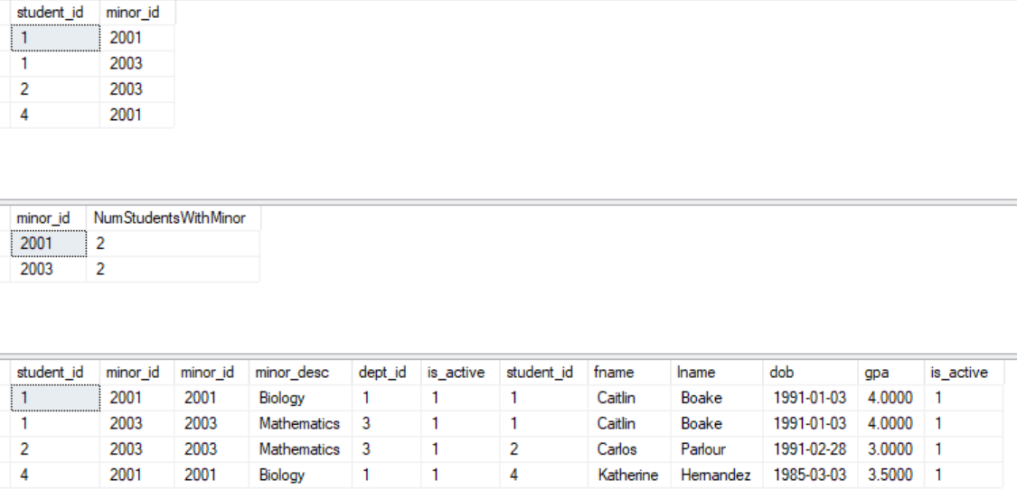

------------------------------------------

---- Student_Addr

----------------------------------------

SELECT * FROM student_addr

--INSERT INTO Student_Addr

--VALUES (1,3)

--UPDATE Student_Addr

--SET address_id = 3

--WHERE student_id = 1 and address_id = 2

--DELETE FROM Student_Addr

--WHERE student_id = 1 and address_id = 3

SELECT student_id, count(address_id) AddressesPerStudent

FROM student_addr

GROUP BY student_id

SELECT * FROM Student_Addr sa

join Address a on a.address_id = sa.address_id

join student s on s.student_id = sa.student_id

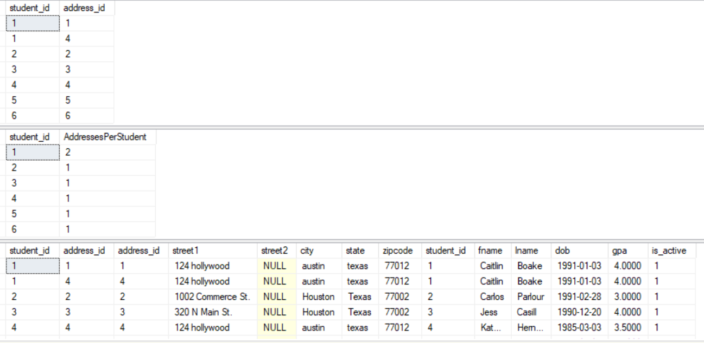

----------------------------------------

---- Staff

----------------------------------------

SELECT * FROM staff

--INSERT INTO Staff

--VALUES (11,'Benjamin','Soibam','Dr.','2999-01-01','Assistant Professor','\\fileshare\c$\share\fileloc\filename2.pdf',1,2)

--UPDATE Staff

--SET cv_file_loc = '\\fileshare\c$\share\fileloc\filename3.pdf' WHERE staff_id = 10

--DELETE FROM Staff

--WHERE staff_id = 11

SELECT count(is_active) num_active_staff

FROM Staff

WHERE is_active = 1

GROUP BY is_active

SELECT * FROM Staff s

join Department d on d.department_id = s.department_id

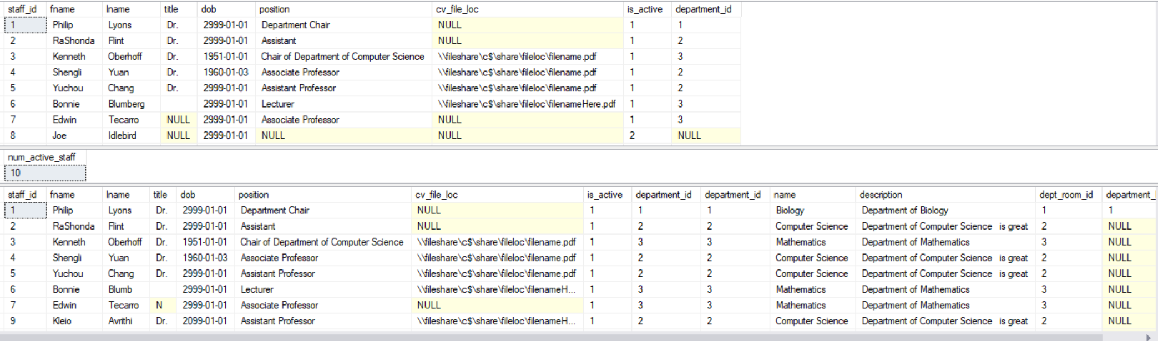

----------------------------------------

---- Staff_Addr

----------------------------------------

SELECT * FROM staff_addr

--INSERT INTO staff_addr

--VALUES (2,5)

--UPDATE staff_addr

--SET address_id =2

--WHERE staff_id = 2

--DELETE FROM staff_addr

--WHERE staff_id = 2

SELECT staff_id, count(address_id) AddressesPerStudent

FROM staff_addr

GROUP BY staff_id

SELECT * FROM staff_addr sa

join Address a on a.address_id = sa.address_id

join Staff s on s.staff_id = sa.staff_id

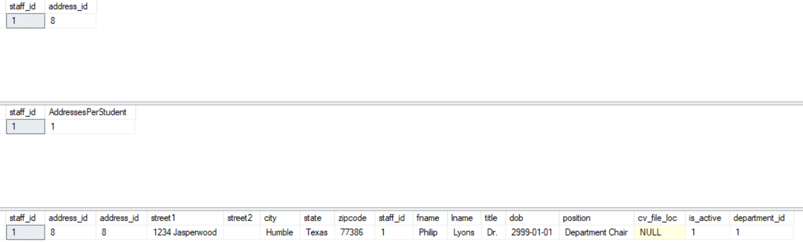

----------------------------------------

---- Department

----------------------------------------

SELECT * FROM department

--INSERT INTO Department

--VALUES (6,'English','Department of English and Literature',null,null)

--UPDATE Department

--SET dept_room_id = 3

--WHERE department_id = 6

--DELETE FROM Department

--WHERE department_id = 6

SELECT COUNT(*) numOfDepartments

FROM Department

SELECT * FROM Department d

left outer join staff ds on ds.staff_id = d.department_head_id

left outer join staff s on s.department_id = d.department_id

left outer join room r on r.room_id = d.dept_room_id

left outer join Major mj on mj.dept_id = d.department_id

left outer join Minor mn on mn.dept_id = d.department_id

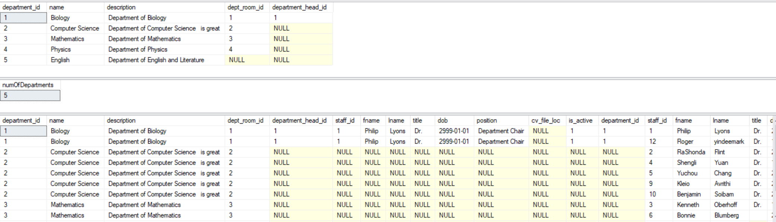

----------------------------------------

---- Course

----------------------------------------

SELECT * FROM Course where course_id = 40678--where course_id = 40025

--INSERT INTO Course

--VALUES (40025,'Introduction to Python','Basic computer science principles using Python',0)

--UPDATE Course

--SET is_active =1

--WHERE course_id = 40023

--UPDATE Course

--SET is_active = 2

--WHERE course_id =40678

--DELETE FROM Course

--WHERE course_id = 40025

SELECT COUNT(*) numCourses

FROM Course

SELECT * FROM Course c

left outer join Course_Dept cd on cd.course_id = c.course_id

left outer join Course_Preq cpr on cpr.course_id = c.course_id

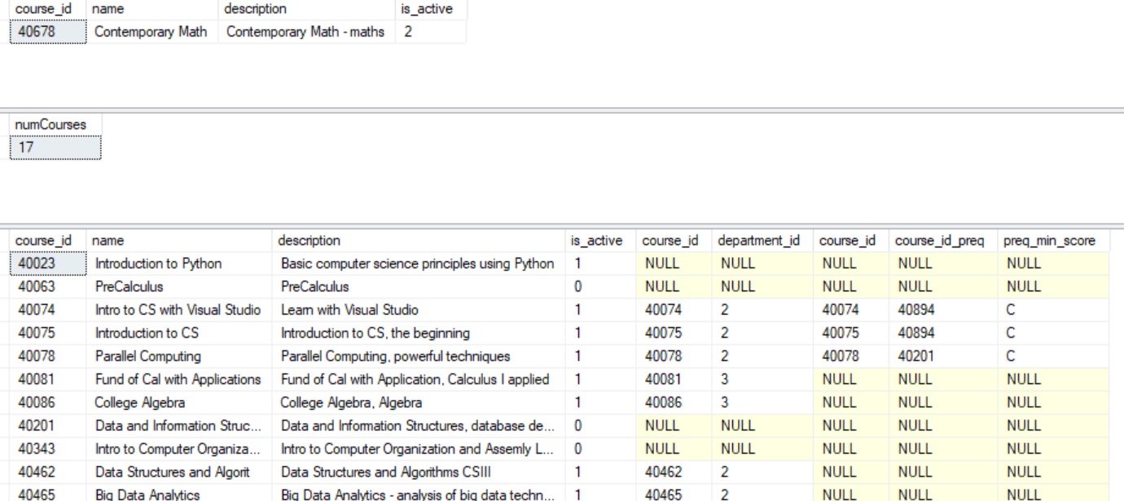

----------------------------------------

---- Course_Dept

----------------------------------------

SELECT * FROM course_dept --where course_id = 40608

--INSERT INTO Course_Dept

--VALUES (40608,3)

--UPDATE Course_Dept

--SET department_id = 5

--WHERE course_id = 40608 and department_id = 3

--DELETE FROM Course_Dept

--WHERE course_id = 40608 and department_id = 5

SELECT course_id, COUNT(distinct department_id) count_dept

FROM course_dept

GROUP BY course_id

SELECT * FROM Course c

join Course_Dept cd on c.course_id = cd.course_id

join Department d on d.department_id = cd.department_id

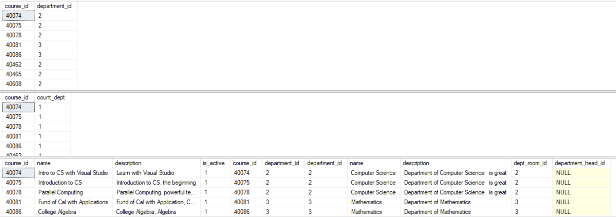

----------------------------------------

---- Course_Preq

----------------------------------------

SELECT * FROM course_preq

--INSERT INTO Course_Preq

--VALUES (43290,40075,'B')

--UPDATE Course_Preq

--SET preq_min_score = 'C'

--WHERE course_id = 43290 and course_id_preq = 40075

--DELETE FROM Course_Preq

--WHERE course_id = 43290 and course_id_preq = 40081

SELECT course_id, count(course_id_preq) num_preq

FROM course_preq

GROUP BY course_id

SELECT c.*, 'has rerequisite course: ' Prerequisite, cpr.* FROM course c

join course_preq pr on pr.course_id = c.course_id

join course cpr on cpr.course_id = pr.course_id_preq

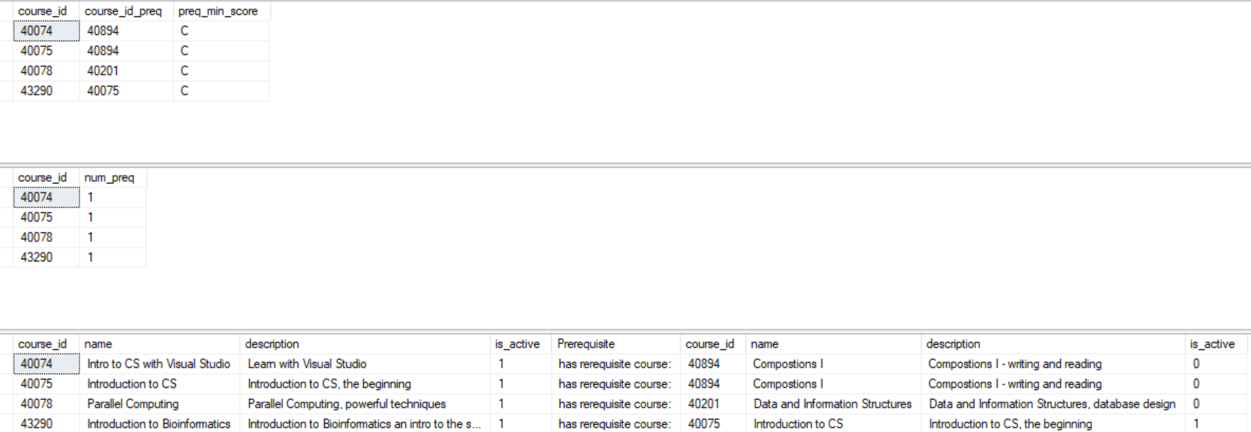

----------------------------------------

---- Class_Listing

----------------------------------------

SELECT * FROM class_listing where class_listing_id = 10

SELECT * FROM Course

--INSERT INTO Class_Listing

--VALUES (10,'Hybrid', 40023,2)

--UPDATE Class_Listing

--SET professor_id = 3

--WHERE class_listing_id = 8

--DELETE FROM Class_Listing

--WHERE class_listing_id = 8

SELECT professor_id, count(course_id) num_courses_for_professor

FROM class_listing

GROUP BY professor_id

SELECT * FROM Class_Listing cl

join Course c on c.course_id = cl.course_id

join staff s on s.staff_id = cl.professor_id

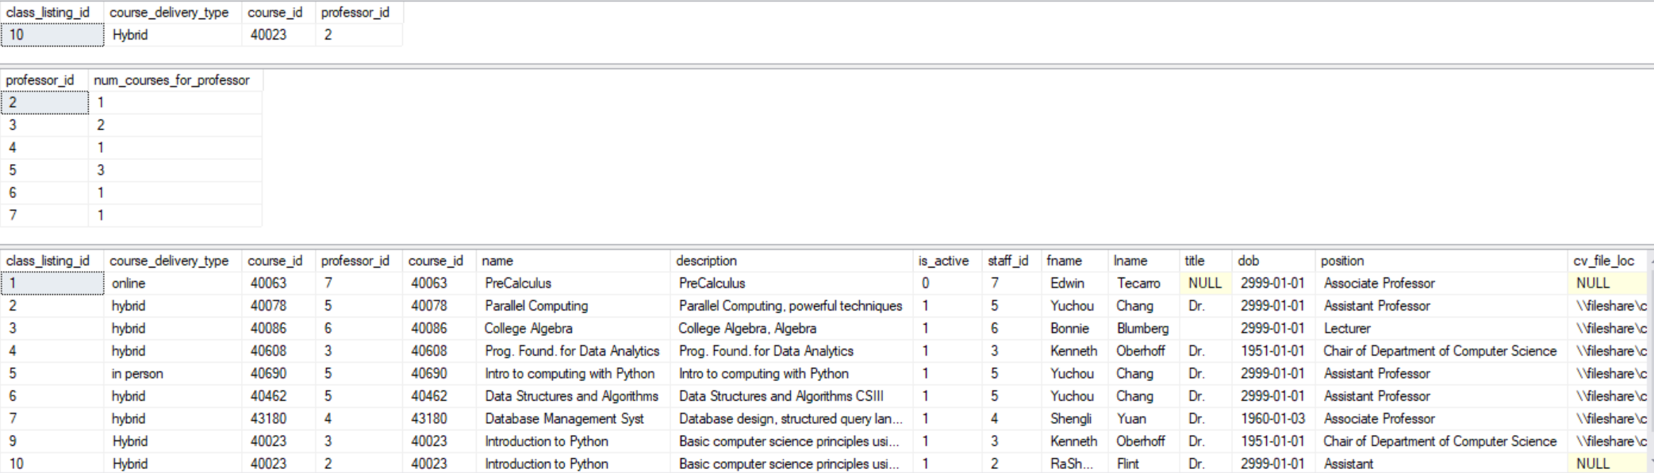

----------------------------------------

---- Class_Room_Occupancy

----------------------------------------

SELECT * FROM class_room_occupancy where room_occupancy_id = 6

--INSERT INTO Class_Room_Occupancy

--VALUES (6,'TH','2018-07-09','2018-08-09','14:45','16:45',10,9)

--UPDATE Class_Room_Occupancy

--SET room_id = 10 WHERE room_occupancy_id = 6

--DELETE FROM Class_Room_Occupancy

--WHERE room_id = 10

SELECT room_id, count(room_id) room_count

FROM class_room_occupancy

GROUP BY room_id

SELECT * FROM Class_Room_Occupancy cro

join Room r on r.room_id = cro.room_id

join Class_Listing cl on cl.class_listing_id = cro.class_listing_id

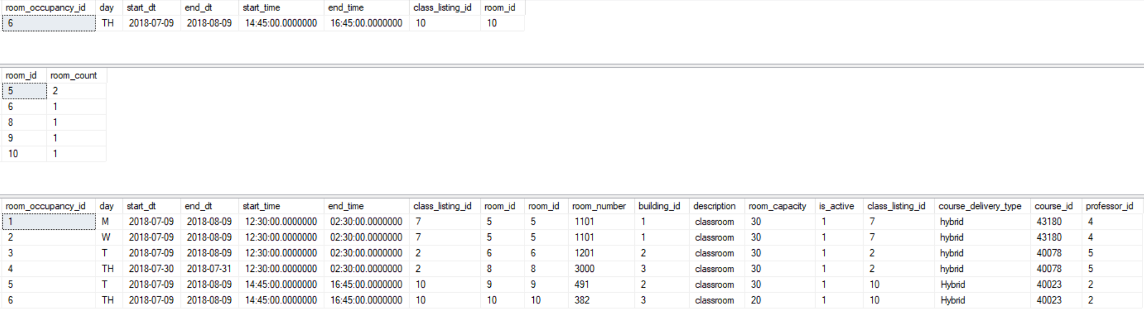

----------------------------------------

---- Class_Registration_Listing

----------------------------------------

SELECT * FROM class_registration_listing

--INSERT INTO Class_Registration_Listing (class_listing_id, student_id)

--VALUES (4,4);

--UPDATE Class_Registration_Listing

--SET rating = 9, comment = 'Enjoyed the class, thank you.'

--WHERE student_id = 1 and class_listing_id = 1

--UPDATE Class_Registration_Listing

--SET grade = 4.0

--WHERE class_listing_id = 7 and student_id = 2

--DELETE FROM Class_Registration_Listing

--WHERE class_listing_id = 4 and student_id = 4

SELECT class_listing_id, count(Student_id) numStudents

FROM Class_Registration_Listing

group by class_listing_id

SELECT a.*, crl.*

FROM Class_Registration_Listing crl

JOIN (

SELECT student_id,count(class_listing_id) num_classes_reg_total

FROM Class_Reg_hist_Listing

WHERE student_id = 1 and reg_dt between '2018-07-01' and '2018-10-01' and dereg_dt is null

GROUP BY student_id) a on a.student_id = crl.student_id

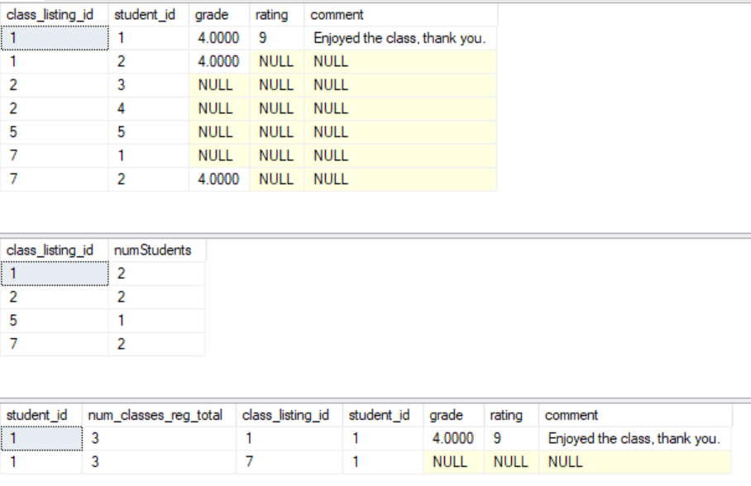

----------------------------------------

---- Class_Reg_History_Listing

----------------------------------------

SELECT * FROM class_reg_hist_listing

--INSERT INTO Class_Reg_Hist_Listing(class_listing_id, student_id, reg_dt)

--SELECT class_listing_id, student_id, CURRENT_TIMESTAMP

--FROM Inserted

-- UPDATE crh

--SET dereg_dt = CURRENT_TIMESTAMP

--FROM Class_Reg_Hist_Listing crh

--JOIN DELETED d on crh.class_listing_id = d.class_listing_id and crh.student_id = d.student_id

--WHERE crh.reg_dt is not null

-- do not delete from this table

SELECT student_id, count(*) numClassesRegHist

FROM class_reg_hist_listing

GROUP BY student_id, class_listing_id

SELECT *

FROM Student s

JOIN Class_Reg_Hist_Listing crh on crh.student_id = s.student_id

join Class_Listing cl on cl.class_listing_id = crh.class_listing_id

WHERE s.fname like '%Caitlin%'

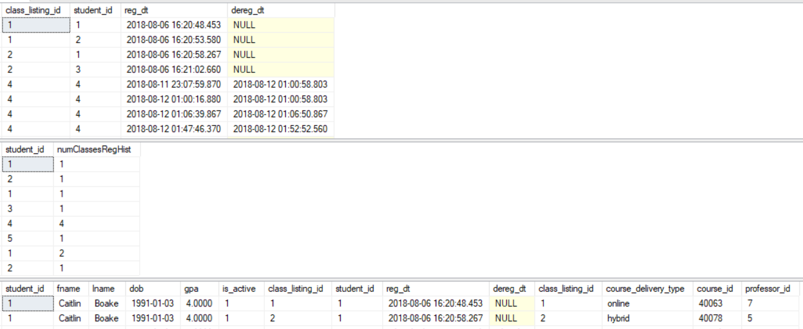

----------------------------------------

---- Graduates

----------------------------------------

SELECT * FROM graduates

--INSERT INTO Graduates

--VALUES(5,'2018-05-14',3.600)

--UPDATE Graduates

--SET final_GPA = '3.5942'

--WHERE student_id = 5

--DELETE FROM Graduates

--WHERE student_id = 5

SELECT count(distinct student_id) numberOfGrads

FROM graduates

SELECT * FROM graduates g

join student s on s.student_id = g.student_id

join Student_Major smj on smj.student_id = s.student_id

join Major m on m.major_id = smj.major_id

left outer join Student_Minor smn on smn.student_id = s.student_id

left outer join Minor mn on mn.minor_id = smn.minor_id

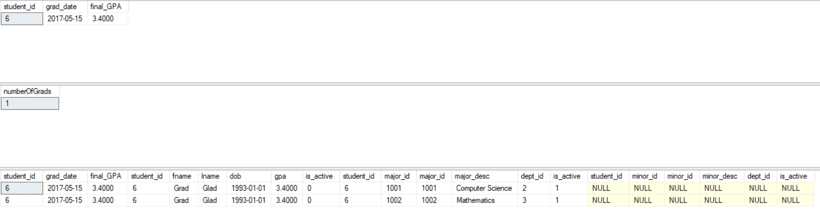

**Tables**

CREATE TABLE University (

University_Id int not null,

Name varchar(255),

Description varchar(4000),

PRIMARY KEY(University_Id)

);

CREATE TABLE Address (

address_id int,

street1 varchar(255),

street2 varchar(255),

city varchar(255),

state varchar(255),

zipcode int,

PRIMARY KEY (address_id)

);

CREATE TABLE Campus (

campus_id int,

description varchar(512),

university_id int REFERENCES University(university_id),

PRIMARY KEY(campus_id)

);

CREATE TABLE Campus_Addr (

campus_id int REFERENCES Campus(campus_id) ON DELETE CASCADE,

address_id int REFERENCES Address(address_id) ON DELETE CASCADE,

PRIMARY KEY(campus_id, address_id)

);

CREATE TABLE Building (

building_id int,

name varchar(255),

description varchar(512),

campus_id int REFERENCES campus(campus_id) ON DELETE SET NULL,

PRIMARY KEY(building_id)

);

CREATE TABLE Building_Addr (

building_id int REFERENCES Building(building_id) ON DELETE CASCADE,

address_id int REFERENCES Address(address_id) ON DELETE CASCADE,

PRIMARY KEY(building_id, address_id)

);

CREATE TABLE Room (

room_id int,

room_number varchar(255),

building_id int REFERENCES Building(building_id),

description varchar(512),

room_capacity int,

is_active tinyint,

PRIMARY KEY(room_id)

);

CREATE TABLE Department (

department_id int,

name varchar(255),

description varchar(512),

dept_room_id int REFERENCES Room(room_id) ON DELETE SET NULL,

department_head_id int REFERENCES Staff(staff_id) ON DELETE SET NULL,

PRIMARY KEY(department_id)

);

CREATE TABLE Staff (

staff_id int not null,

fname varchar(255) not null,

lname varchar(255) not null,

title varchar(5),

dob date,

position varchar(255),

cv_file_loc varchar(512),

is_active tinyint,

PRIMARY KEY(staff_id)

);

ALTER TABLE Staff ADD department_id int REFERENCES Department(department_id)

CREATE TABLE Staff_Addr (

staff_id int REFERENCES Student(student_id) ON DELETE CASCADE,

address_id int REFERENCES Address(address_id) ON DELETE CASCADE,

PRIMARY KEY(staff_id, address_id)

);

CREATE TABLE Course (

course_id int,

name varchar(255),

description varchar(4000),

is_active tinyint,

PRIMARY KEY(course_id)

);

CREATE TABLE Course_Dept (

course_id int REFERENCES Course(course_id),

department_id int REFERENCES Department(department_id) ON DELETE SET NULL,

PRIMARY KEY(course_id, department_id)

);

CREATE TABLE Course_Preq (

course_id int REFERENCES Course(course_id),

course_id_preq int REFERENCES Course(course_id),

preq_min_score varchar(1),

PRIMARY KEY(course_id, course_id_preq)

);

CREATE TABLE Class_Listing (

class_listing_id int,

course_delivery_type varchar(255),

course_id int REFERENCES Course(course_id),

professor_id int REFERENCES Staff(staff_id),

PRIMARY KEY(class_listing_id)

);

CREATE TABLE Class_Room_Occupancy (

room_occupancy_id int,

day varchar(2),

start_dt date,

end_dt date,

start_time time,

end_time time,

class_listing_id int REFERENCES Class_Listing(class_listing_id) ON DELETE CASCADE,

room_id int REFERENCES Room(room_id) ON DELETE CASCADE,

PRIMARY KEY(room_occupancy_id)

);

CREATE TABLE Student (

student_id int,

fname varchar(255),

lname varchar(255),

dob date,

gpa decimal(5,4),

is_active tinyint,

PRIMARY KEY(student_id)

);

CREATE TABLE Graduates (

student_id int REFERENCES Student(student_id),

grad_date date,

final_GPA decimal(5,4),

PRIMARY KEY(student_id, grad_date)

);

CREATE TABLE Major (

major_id int,

major_desc varchar(255),

dept_id int REFERENCES Department(department_id) ON DELETE SET NULL,

is_active tinyint,

PRIMARY KEY(major_id)

);

CREATE TABLE Minor(

minor_id int,

minor_desc varchar(255),

dept_id int REFERENCES Department(department_id) ON DELETE SET NULL,

is_active tinyint,

PRIMARY KEY(minor_id)

);

CREATE TABLE Student_Major(

student_id int REFERENCES Student(student_id) ON DELETE CASCADE,

major_id int REFERENCES Major(major_id) ON DELETE CASCADE,

PRIMARY KEY(student_id, major_id)

);

CREATE TABLE Student_Minor(

student_id int REFERENCES Student(student_id) ON DELETE CASCADE,

minor_id int REFERENCES Minor(minor_id) ON DELETE CASCADE,

PRIMARY KEY(student_id, minor_id)

);

CREATE TABLE Student_Addr (

student_id int REFERENCES Student(student_id) ON DELETE CASCADE,

address_id int REFERENCES Address(address_id) ON DELETE CASCADE,

PRIMARY KEY(student_id, address_id)

);

CREATE TABLE Class_Registration_Listing (

class_listing_id int REFERENCES Class_Listing(class_listing_id),

student_id int REFERENCES Student(student_id),

grade decimal(5,4),

rating smallint,

comment varchar(4000),

PRIMARY KEY(class_listing_id, student_id)

);

CREATE TABLE Class_Reg_Hist_Listing (

class_listing_id int REFERENCES Class_Listing(class_listing_id),

student_id int REFERENCES Student(student_id),

reg_dt datetime,

dereg_dt datetime,

PRIMARY KEY(class_listing_id, student_id, reg_dt)

);

**Database Prototype**

We are going to use SQL server to create our database.

**Project Time Table**

|  |  |  |
| --- | --- | --- |
| Task | Team Member | Date |
| Finish E/R Diagram |  |  |
| Complete Database Design |  |  |
| Complete Case Relations |  |  |
| Provide the complete SQL statements, or relational algebra operations for every use case. |  |  |
| Complete SQL Schema |  |  |
| Begin Constructing Database using SQL server |  |  |
| Test Database |  |  |
| Continue Database testing |  |  |
| Complete conclusion and reference |  |  |
| Complete Database Functionalities and User Interface Views |  |  |

**Conclusion**

**References**